**Assignment: module -5**

**Network Fundamentals and Building Networks**

**Section 1: Multiple Choice**

1. What is the primary function of a router in a computer network?

Ans:- c) Forwarding data packets between networks.

1. What is the purpose of DHCP (Dynamic Host Configuration Protocol) in a

computer network?

Ans:- d) Dynamically assigning IP addresses to devices

1. Which network device operates at Layer 2 (Data Link Layer) of the OSI model and for forwards data packets based on MAC addresses?

Ans:- b) Switch

1. Which network topology connects all devices in a linear fashion, with each device to a central cable or backbone connected?

Ans:- b) Bus

**Section 2: True or false**

5.A VLAN (Virtual Local Area Network) allows network administrators to logically segment a single physical network into multiple virtual networks, each with its own broadcast domain**.**

**Ans:-** **True**

6.TCP (Transmission Control Protocol) is a connectionless protocol that provides reliable, ordered, and error-checked delivery of data packets over a network.

**Ans:-False**

7. A firewall is a hardware or software-based security system that monitors and controls incoming and outgoing network traffic based on predetermined security rules.

**Ans:- True**

**Section 3: Short answer**

8. Describe the steps involved in setting up a wireless network for a small office or home office (SOHO) environment.

Ans:- STEPS :- Connect the modem and router

* Place the router optimally
* Access and secure the router interface
* Set up wireless network basics
* Enable additional security features
* Connect devices and test connectivity

**Section 4: Practical**

9.Demonstrate how to configure a router for Internet access using DHCP (Dynamic Host ConfigurationProtocol).

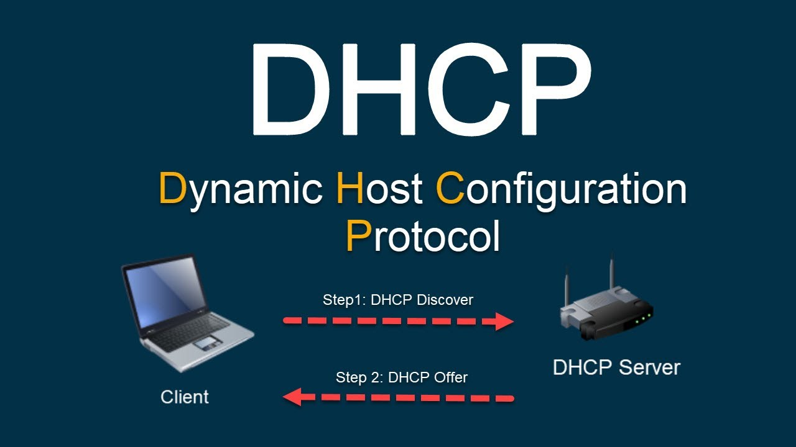

Ans :- **1. Access the router's administration interface:**

* + Open a web browser on a device connected to the router.
  + Enter the router's IP address (usually 192.168.1.1 or 192.168.0.1, but refer to your router's manual for the specific address) into the address bar.
  + Log in using the router's username and password.

**2. Navigate to DHCP settings:**

* + Find the section related to LAN or network configuration. This may be labeled "LAN", "Network", "DHCP Server", or similar.
  + Locate the DHCP settings within that section.

**3. Enable the DHCP server:**

* + Check the box or toggle the switch to enable the DHCP server.

**4. Configure the DHCP scope:**

* + **IP Address Range:** Define the range of IP addresses that the router will assign to devices.
  + **Subnet Mask:** Set the subnet mask (e.g., 255.255.255.0).
  + **Gateway:** Enter the router's IP address as the gateway.
  + **DNS Servers:** Specify the DNS server(s) (e.g., Google's public DNS: 8.8.8.8 and 8.8.4.4).
  + You may also need to configure other settings like lease time (how long a device can use an assigned IP).

**5. Save and restart:**

* + Click "Save", "Apply", or a similar button to save the changes.
  + Restart the router to activate the new settings.

**Section 5: Essay**

10. Discuss the importance of network documentation in the context of building and managing networks.

Ans :- Network documentation is a critical component in building and managing computer networks. It involves creating detailed records of the network's components, configurations, and connections, serving as a comprehensive reference for IT professionals.

**Key Reasons for Network Documentation**

1. **Enhanced Troubleshooting and Maintenance**  
   Detailed documentation allows IT staff to quickly identify and resolve issues, reducing downtime and improving system reliability.
2. **Knowledge Retention and Transfer**  
   Proper documentation preserves institutional knowledge, ensuring that critical information is not lost when team members leave or transition roles.
3. **Compliance and Regulatory Adherence**  
   Many industries require detailed records of network configurations and security measures. Documentation helps organizations meet these regulatory requirements and avoid potential fines.
4. **Efficient Change Management**  
   Keeping accurate records of network changes ensures that modifications are tracked, facilitating better planning and minimizing the risk of errors during updates or expansions.
5. **Improved Security Posture**  
   Comprehensive documentation aids in identifying potential security vulnerabilities and ensures that appropriate measures are in place to protect the network infrastructure.